Order of Discussion by Dataset

1. Simulated (pg 1)
2. SoccerPL (pg 2)
3. Cars (pg 4)
4. German (pg 6)
5. Idea (pg 9)
6. APA (pg 10)

**Simulated Dataset**

We built a simulated dataset of 10,000 ranks with 4 ranking elements each. This dataset assumed a ground truth of [1, 2, 3, 4]. The weights were arithmetic, with *a*=1.0 and *b*=0.33. The weights-vector will then be: [1, 0.67, 0.33].

Next, we used the gradient ascent algorithm on this simulated dataset attempting to look for the ground truth using maximum log likelihood.

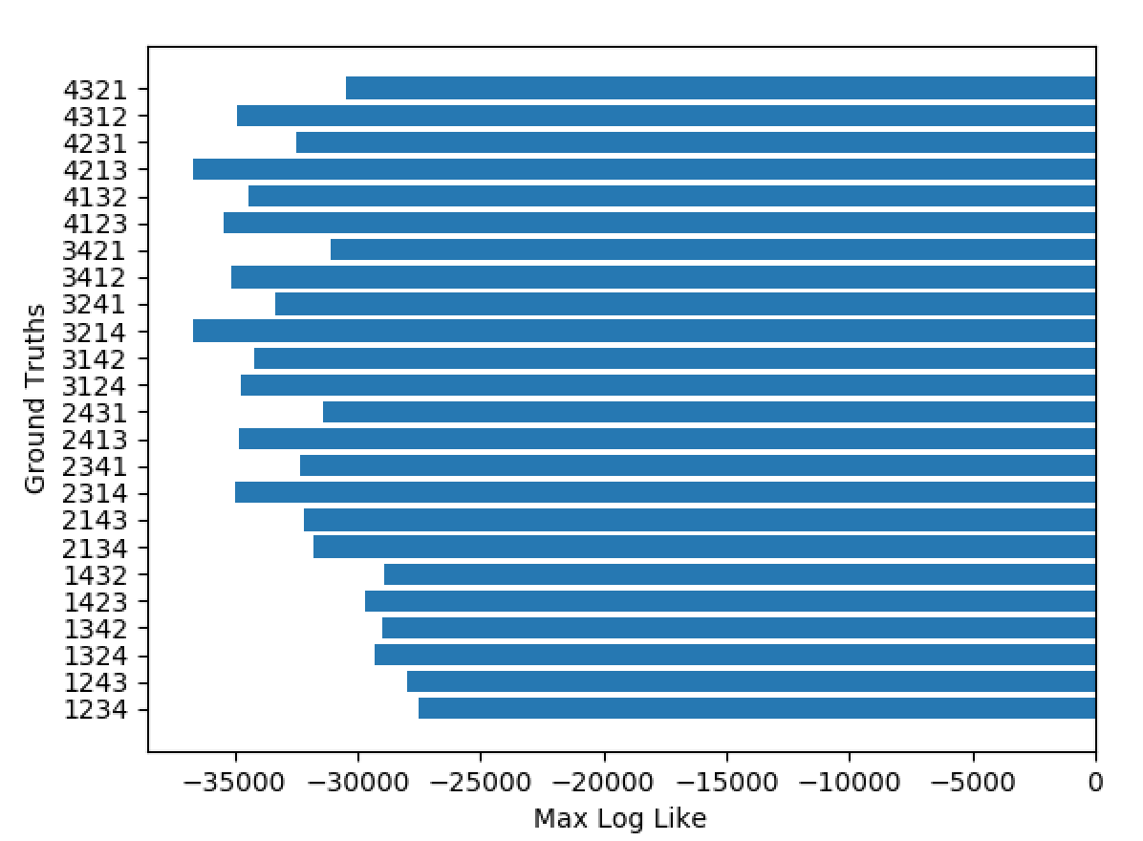

Figure 1. Simulated datasets across all possible ground truths

In Figure 1, we see that the maximum log-likelihood occurs for the ground truth: [1, 2, 3, 4]. However, it’s interesting to note that the values [4,3,2,1] has a relatively high max-log likelihood. This does not make sense because [4,3,2,1] based off the weighting schemes should have a very low likelihood of being the ground truth for this simulated dataset.

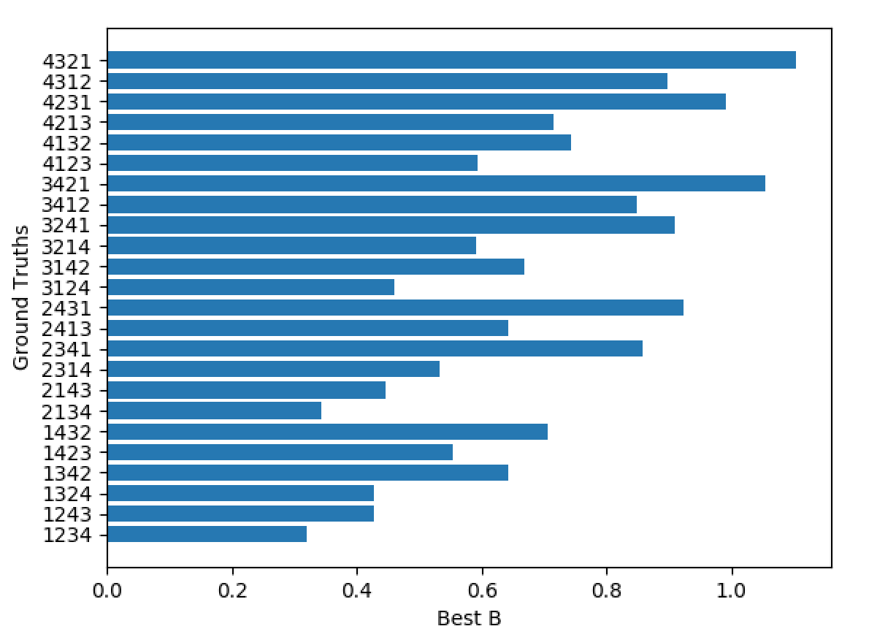

Figure 2. Best ‘b’ values for each possible ground truth in simulated data.

When we looked at the b-values for each ground truth in Figure 2., we see something that makes more sense. For the ground-truth of [1,2,3,4], we see that the gradient ascent algorithm was able to correctly determine the true b-value of 0.33. And we also see that [4,3,2,1] has an impossible value of b (>1.0) that skews the maximum likelihood for that ground-truth in Figure 1.

**SoccerPL Dataset**

Premier league ranks for 4 teams for 21 seasons

Data:

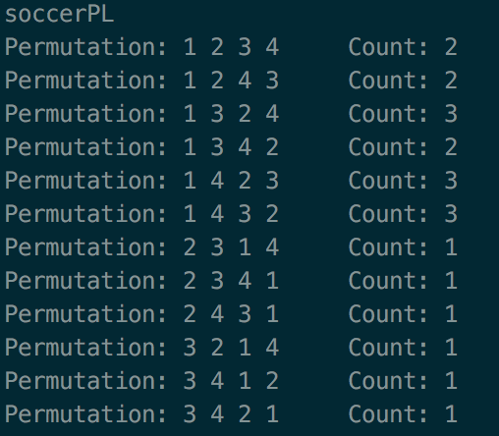

Figure 3. Distribution of Soccer PL data

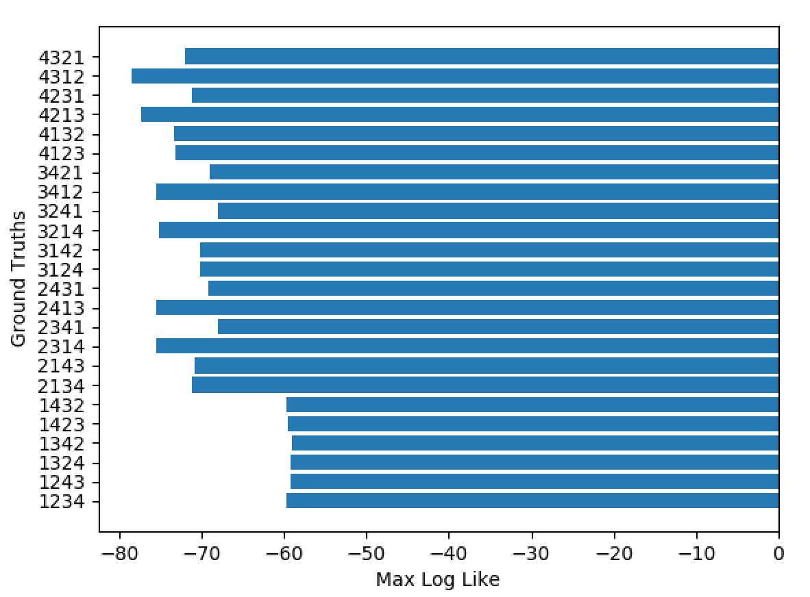

Figure 4. Max-log Likelihood of SoccerPL dataset across all ground truths

Given the high frequency of ranks with 1 in the first position (Figure 3), it makes sense that the most-likely ground truth will be those that have 1 in the first position in Figure 4. The relatively small amount of data obtained makes it difficult to determine the true ground-truth.

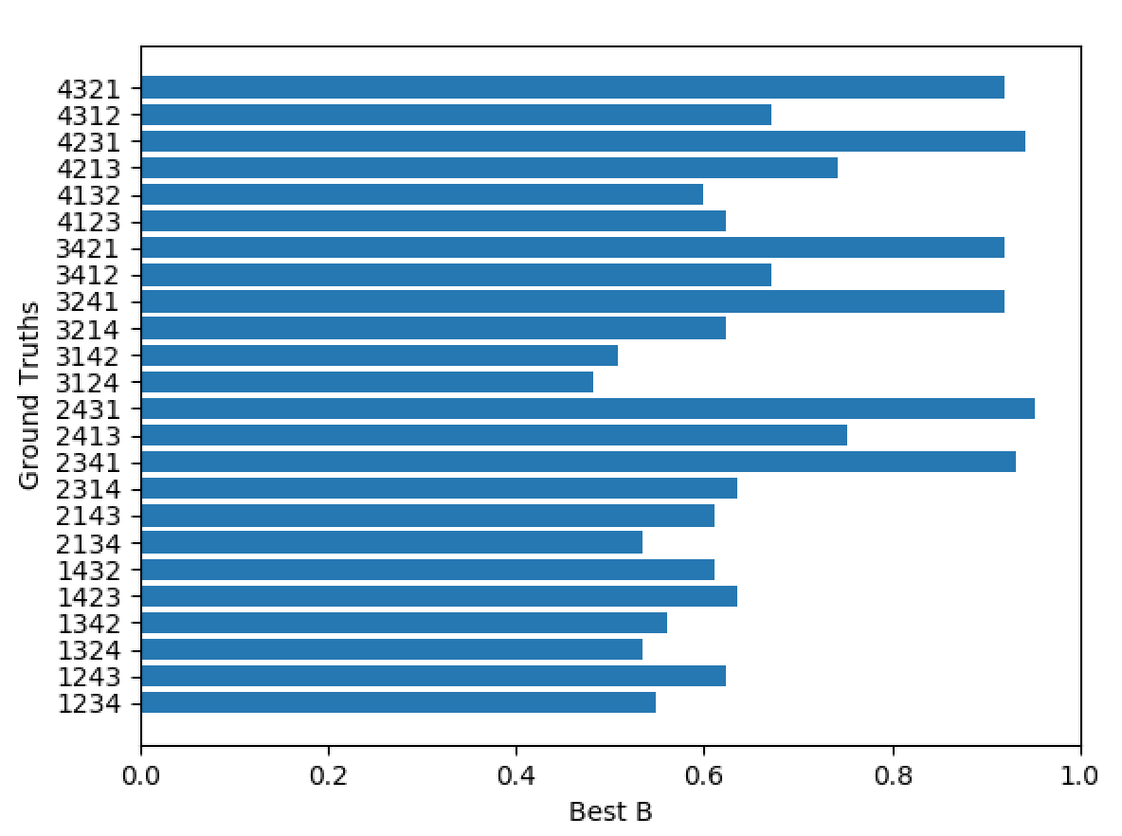

Figure 5. Best ‘b’ values for each possible ground truth in SoccerPL data

When we try to look at the b-vectors, all of them have b-values that will create negative weights. We hypothesize that the few number of observations of the dataset and relative uniformity of the data is to blame for these impossible b-values.

**Cars Dataset**

279 Spanish college students were asked to rank 4 compact cars according to their purchase preferences. The authors provide the ranking patterns' observed frequencies in this sample.

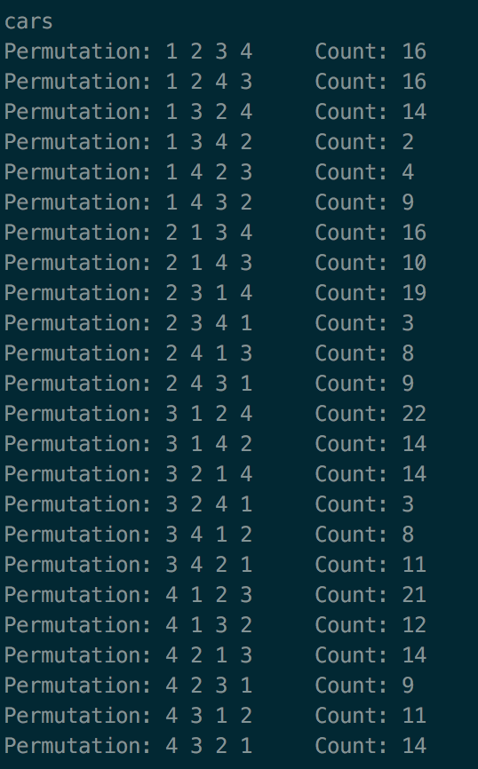

Figure 6. Distribution of cars data

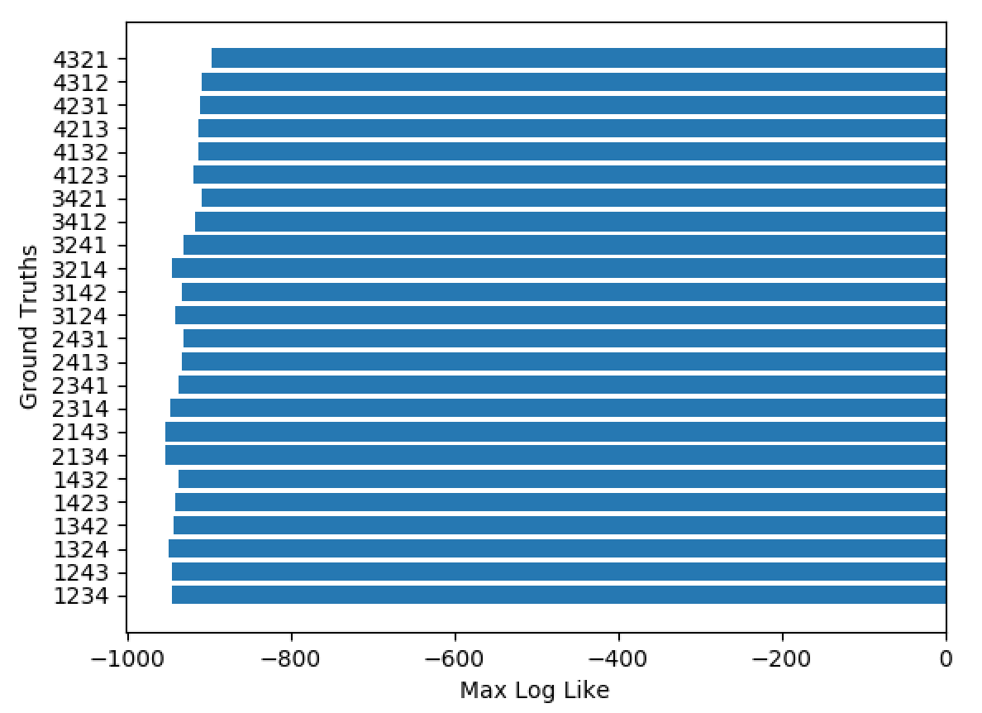

Figure 7. Max-log Likelihood of cars dataset across all ground truths

The maximum log-likelihood appears to be much more uniformly distributed across ground truths in this case, which somewhat reflect the data. Here we can see that [4,3,2,1] is the most-likely ground-truth.

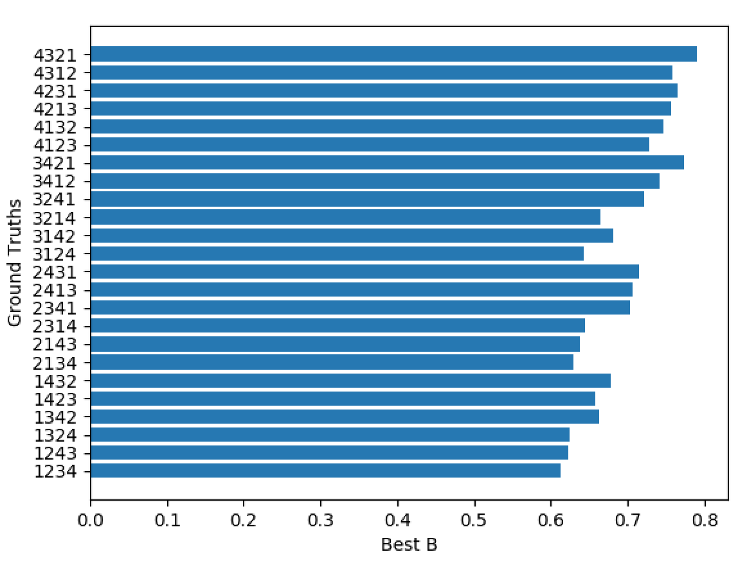

Figure 8. Best ‘b’ values for each possible ground truth in cars data

Unfortunately, all the b-values that produced maximum log-likelihoods would also produce negative weights.

**German**

Croon’s ranking data of 2262 German respondents about the desirability of the four political goals (1989):

(1) the maintenance of order in the nation;

(2) giving people more say in the decisions of government

(3) fighting rising prices

(4) protecting freedom of speech.

<https://onlinelibrary.wiley.com/doi/pdf/10.1348/000711099158973>

Data:

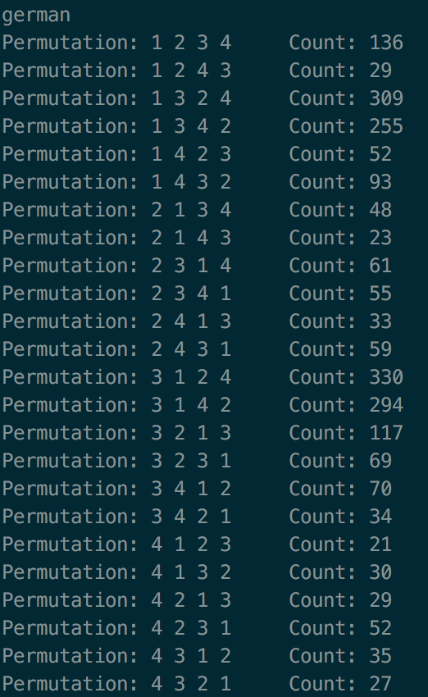

Figure 9. Distribution of German data

There are two distinct modes in the data: 1324 and 3124. Our model should theoretically be able to predict either of these two (or slight deviances from the permutations) as the most likely ground truth.

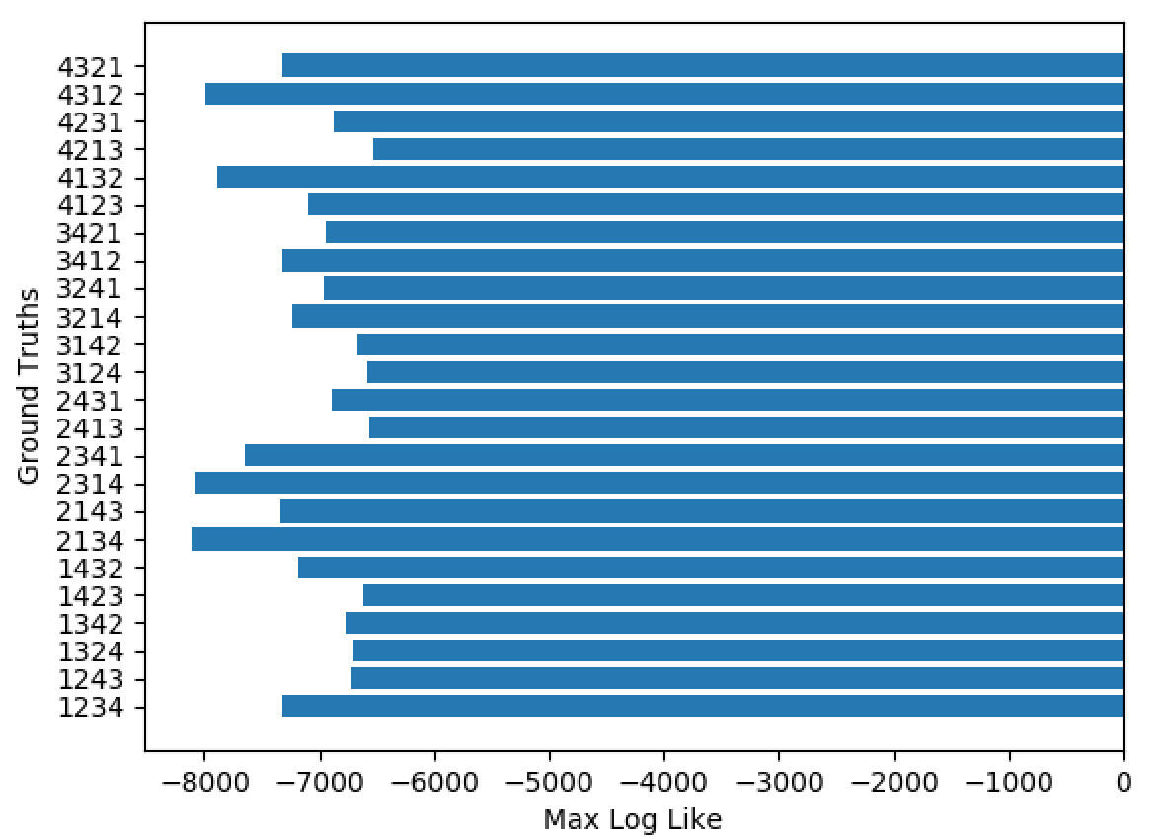

Figure 10. Max-log Likelihood of German dataset across all ground truths

We can see that ground truths 1324 and 3124 appear to have among the highest max log-likelihoods. However, in Figure 11, the most-likely ground truth from the data is 4213, with a max log-like of exactly -6534.13. This does not make sense since 4213 and any of its close permutations are nowhere near the modes identified above. When we look at the b-values, we see that 4213 produces an invalid b of 1.135, much greater than the maximum of b=0.5. Note that the value of 0.5 comes from 1/(n-2), where n is the number of ranking elements.

What might be best is to limit b to be less than 0.5, and then look at maximum log-likelihoods.

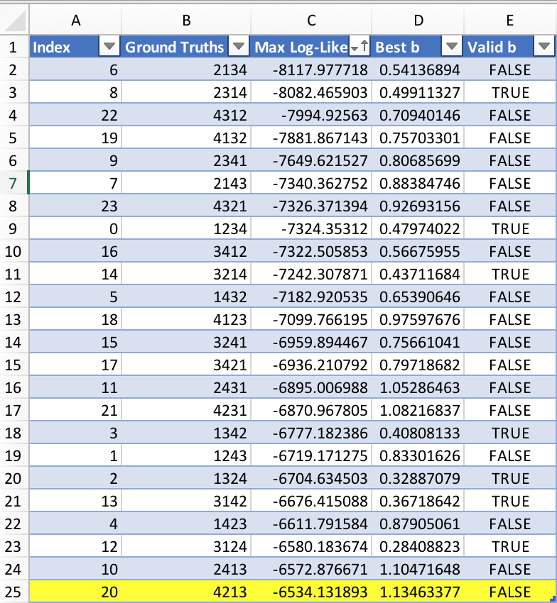

Figure 11. German ground truths ranked by max log-likelihoods.

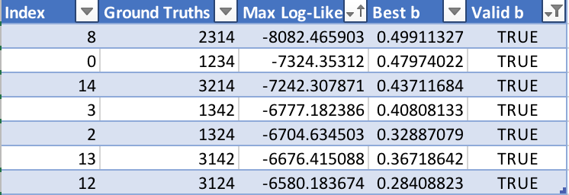

Figure 12. German ground truths ranked by max log-likelihoods but filtered by valid b.

Filtering by b<=0.5, we see 3124 and 1324 as the highest log-likelihoods. This seems to much more accurately reflect the data.

**Idea**

A sample of 98 college students were asked to rank five words according to strength of association with the target word "Idea": 1= Thought, 2 = Play, 3 = Theory, 4= Dream and 5 = Attention.

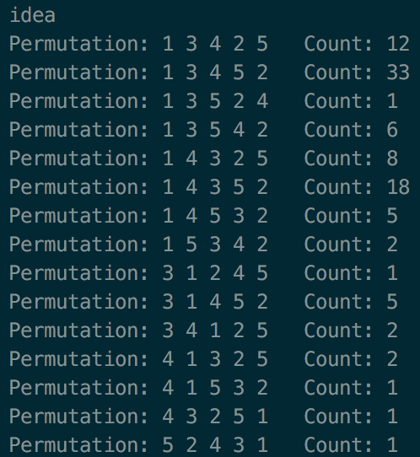

Figure 13. Distribution of idea data

In Figure 13, we see a clear single mode of 13452, with close permutations 14352 and 13425 as the next highest in frequency.

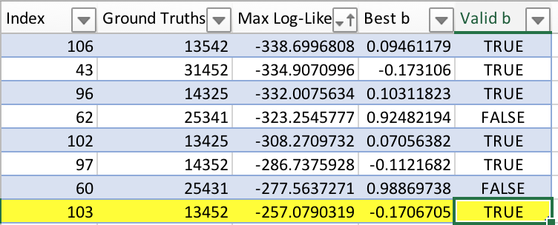

Figure 14. Idea ground truths ranked by max log-likelihoods (partial output)

The model was able to accurately discern the ground-truth 51432 even without limiting b. The b value for this ground-truth is valid because it would not produce negative weights as it is not greater than .

**APA**

This dataset contains the 5738 full rankings resulting from the American Psychological Association (APA) presidential election of 1980. For this election, members of APA had to rank five candidates in order of preference.

See Figure 15 in appendix for frequency distribution of APA dataset. With closer inspection, there appear to be two modes: 31254 and 54123, with frequency counts of 186 and

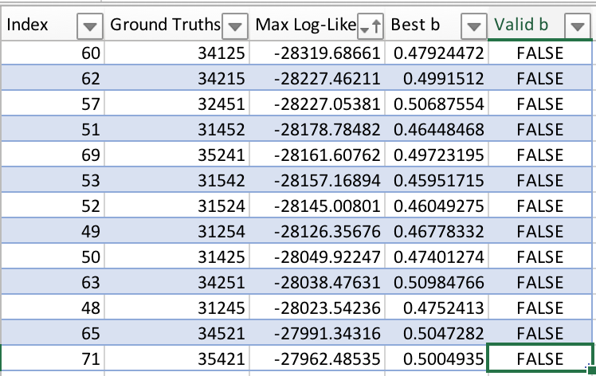

Figure 16. APA ground truths ranked by max log-likelihoods (partial output)

Overall, the model was *not* able to accurately discern either of the modes. The ground truth corresponding to the highest maximum likelihood (35421) had a very low count (43) in the actual data. The ground truth of 31254 had the 6th highest maximum log-likelihood out of 120possible ground truths, which is relatively not that bad.

Unfortunately, all b-values produced by this model were greater than 1/3, including those of the true modes in the distribution.

**Appendix**

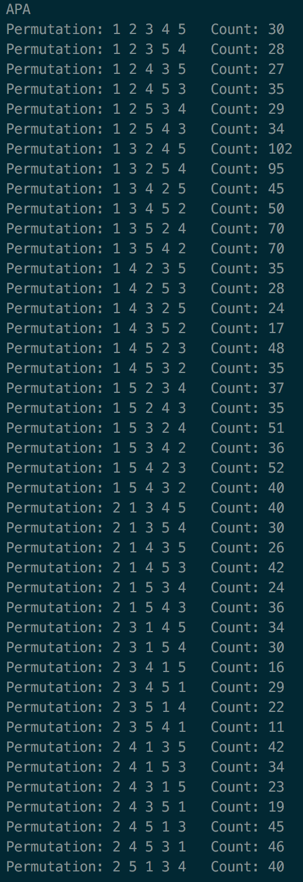 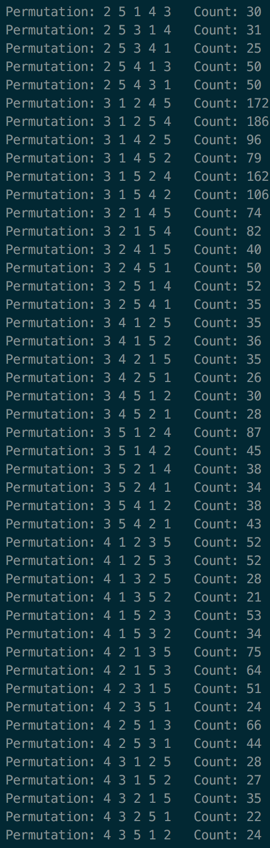 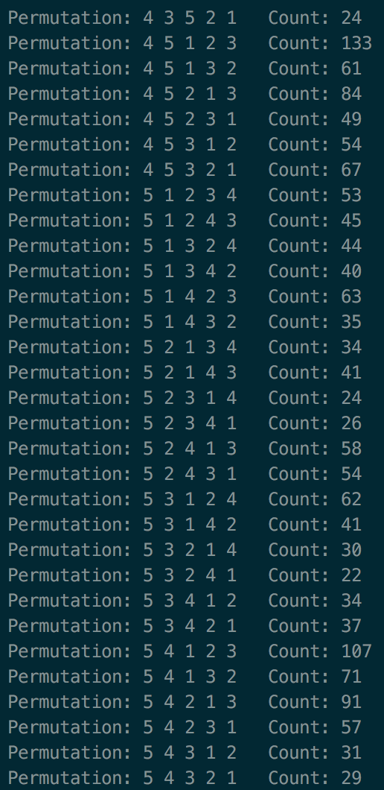

Figure 15. Distribution of APA dataset